1. Create new data source in Grafana

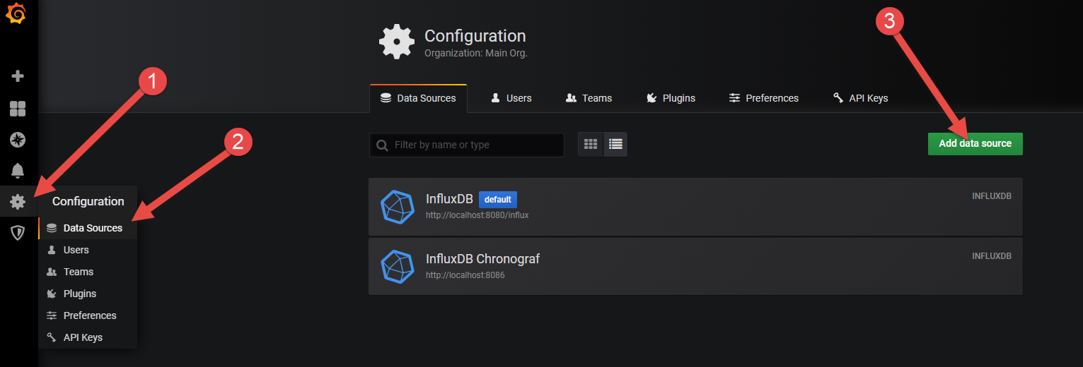

1. Configure InfluxDB datasource in order to get list of alerts

